#### Software engineering [Project Proposal](https://fhsu.blackboard.com.cn/webapps/assignment/uploadAssignment?content_id=_120870_1&amp;course_id=_314_1&amp;group_id&amp;mode=view) 22/3/2019

**Application of traffic monitoring in navigation software**

Team: Shadowrocket

Team Member:

|  |  |
| --- | --- |
| Name | FHSU ID |
| William | 66195207 |
| Chandler | 66088445 |
| Palmer | 23137342 |
| Caden | 84751102 |
| Guy | 84651951 |
| Jay | 49038231 |

Table of Contents

Page Title

Functional Requirements Specification User Interface Specification

**Functional Requirements Specification**

## Stakeholders

1. User
2. System administrator
3. Traffic management personnel
4. Investment company

## Actors and Goals

Users need to access the main program to solve their own travel problems to understand the travel modes and travel directions they need.

The system administrator (initiating participant) administrator can run the system software normally, and solve the upgrade software according to the vulnerabilities and problems that occur in the software.

The application (participating participant) application is sent to the user in various ways (sound, text, image, etc.) and the program obtains the optimal result by calculating various factors affecting the user's travel.

The application can only be run on the mobile side through the App form.

The goal of the location search service is to determine where the user is located and the buildings around them.

The goal of the route service is to provide users with a fast arrival route after a large amount of calculations after the user enters the destination.

The goal of the virtual map service is to provide users with buildings (restaurants, pedestrian streets, etc.) around their destinations while viewing the map. If users are interested in certain locations, they can directly click on the relevant locations on the virtual map. operating

The purpose of the weather service is to provide the user with the detailed weather of their destination for the last fifteen days based on the user entering the destination they want to go, so that the user can be prepared.

The database stores data for all users on our software, which can be used to get results as fast as possible through data analysis.

The app will first access the user's last 15 days of travel plans and determine where they are located. It will show the user's location in a flat map, and of course provide a virtual map for the user. After the user enters the destination, it will provide all the travel modes from the user's departure point to the destination. After the user further selects the travel mode, it will display the real-time situation

of the route road and the weather conditions, and predict the possible problems of the road. To provide users with alternatives, after the user has a problem, the software can further provide solutions according to the problems generated by the user until the user reaches the destination that needs to arrive accurately.

Providing route and weather services is controlled by the administrator.

Provide location reports to users through location services configured on their smartphones. At the same time, the user is allowed to react to the live situation of the road through the App and store it in the database.

## Use Cases

**REQ1: Add user**

**REQ2: User location targeting REQ3: Enter the destination**

**REQ4: Enter the estimated departure time or arrival time REQ5: Route planning and feedback to users**

**REQ6: User chooses the best way to travel REQ7: Add departure reminder**

**REQ8: Modify plan (optional)**

USE CASE 1：Log in

|  |
| --- |
| USE CASE 1*：*Log in |
| **Related Requirem’ts:** REQ1, REQ7, REQ8  **Initiating Actor:** User  **Actor’s Goal:** Want to be able to record their own query results and history.  **Participating Actors:** User, Smart Phone  **Preconditions:** Software has the ability to create, store, and identify user credentials.  **Postconditions:** Provide login feedback.  **Flow of Events for Main Success Scenario:**  *→*User provides login request to software  *←*Provide user login interface  *←*User input credentials  *←*verify login credentials  *←*Successful verification (user login) / verification failed (re-enter credentials)  **Flow of Events for Extensions (Alternate Scenarios):**  *→*User provides login request to software  *←*Provide user registration interface  *→*User created credentials |

*←*Save credentials and feedback to the user

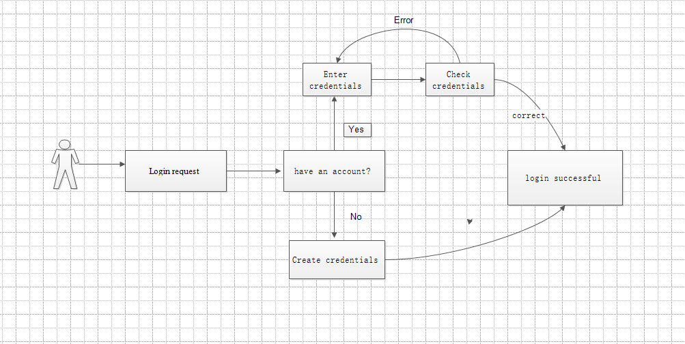

## Use Case-2：Query route

|  |
| --- |
| Use Case 2：Query route |
| Related Requirements: REQ2 and REQ3 Initiating Actor: User  Actor’s Goal: To locate and get directions Participating Actors: Traffic database, User  Preconditions: The user registers and logs in to the software, and the software locates the user in real time and analyzes the data.  Postconditions: The software records the navigation route in the traffic database  Flow of Events for Main Success Scenario:   1. The user logs in to the navigation software. 2. The system updates the map to locate the user's location in real time. 3. The system prompts the user to enter a destination. 4. The user enters the destination and submits. 5. The system prepares a data query that best matches the user's search criteria. 6. Through the traffic database query, the system handles. 7. Data feedback and plan the best route. 8. System (a) displays the selected record and confirms the request; (b)   archives the request in the database and routes it; (c) displays the route and navigates in real time. |

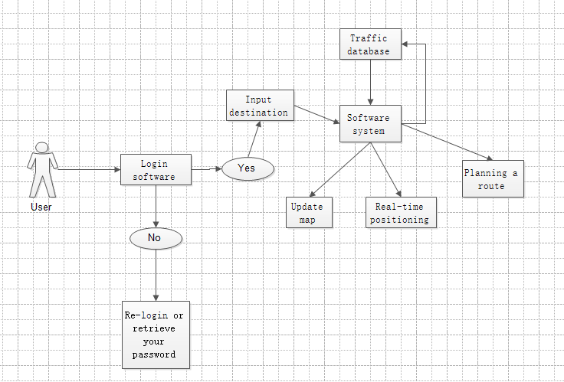

### Use Case 3：User Location

|  |  |
| --- | --- |
| User case | User Location |
| Related Requirem’ts | Open Mobile GPS Access |
| Initiating Actor | user |
| Actor’s Goal | Open position, automatic positioning |
| Participating Actors | Smart phones, hands,GPS |
| Preconditions | Have the location and storage rights of mobile phones. Open APP |
| Postconditions | Open GPS |
| Flow of Events for Main Success Scenario | 1.Open APP at the current location 2.Enter the search button 3.Display the current location |

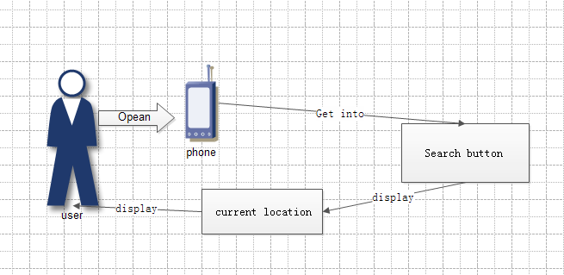

Use Case 4：User Location

|  |  |
| --- | --- |
| User case | Route planning and feedback to users |
| Related Requirem’ts | Open the mobile phone GPS access. |
| Initiating Actor | user |
| Actor’s Goal | Open position, automatic positioning |
| Participating Actors | Smartphones, Hands, GPS |
| Preconditions | Have the location and storage rights of mobile phones. Open APP. |
| Postconditions | Running Settable Preferences Algorithms. |
| Flow of Events for Main Success Scenario | 1. Open APP at the current location 2. Enter the search button 3. Display the current location 4. Input destination 5. Choosing Personal Preferences 6. Display personal paths |

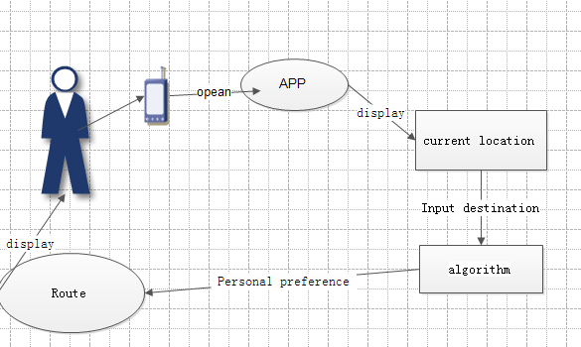

**Use Case 6: Choose a travel plan**

|  |  |
| --- | --- |
| Use Case 6*：* | Choose a travel plan |
| Related Requirem’ts: | REQ3*，*REQ4*，*REQ6 |
| Initiating Actor: | User |
| Actor*‘*s Goal | The user chooses the system to plan the plan that best suits his or  her travels. |
| Participating Actors: | Database, User |
| Preconditions: | User enters his own destination departure time  The system generates and  develops a variety of plans for users to choose |

|  |  |
| --- | --- |
| Postconditions: | Nothing worth mentioning |
| Flow of Events for Main Success Sccnario: | 1. Multiple optional travel plans appear on the user software interface 2. The user selects one according to their own time and enters 3. After entering, you can view the simulation and see if you are   satisfied. |

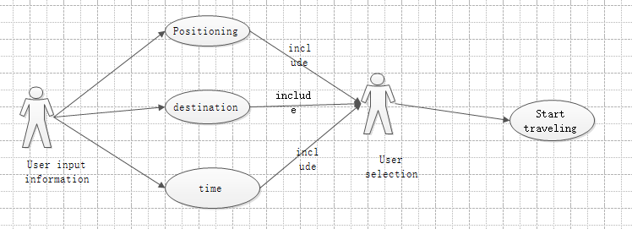

|  |
| --- |
| USE CASE 7*：*Add a departure reminder |
| **Related Requirem’ts:** REQ1, REQ6, REQ7  **Initiating Actor:** User  **Actor’s Goal:** Want to be reminded at a specific time before departure.  **Participating Actors:** User, Smart Phone |

**Preconditions:** The user has made a travel plan and the phone has a reminder function.

**Postconditions:** Mobile phone vibration / ring alert

**Flow of Events for Main Success Scenario:**

*→*User input is reminded by mobile phone before (?) minutes/hour before travel.

*←*Software saved and transmitted to the phone alarm clock software.

*←*Alarm reminder

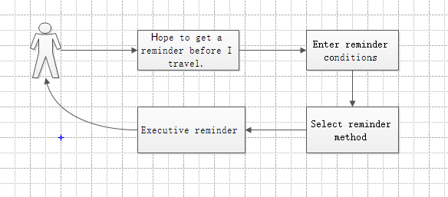

## Use Case 8

|  |  |
| --- | --- |
| Use Case 8*：* | Modify travel plan |
| Related Requirem’ts: | REQ6*，*REQ8 |
| Initiating Actor: | *系统* |
| Actor‘s Goal | The system selects the avoided road based on the sudden situation of the road condition received by the feedback, and the system regenerates the plan. |
| Participating Actors: | database |
| Preconditions: | The user has feedback on the road condition, and the system receives an unexpected situation in the |

|  |  |
| --- | --- |
|  | planned road conditions for the user. |
| Postconditions: | Nothing worth mentioning |
| Flow of Events for Main Success Sccnario: | 1. 1. Have feedback from the user about the road condition or the system collects information about the condition of the road. 2. 2. There are unexpected situations in the planned road conditions of the user in the database. 3. 3. Remind users to regenerate the plan |

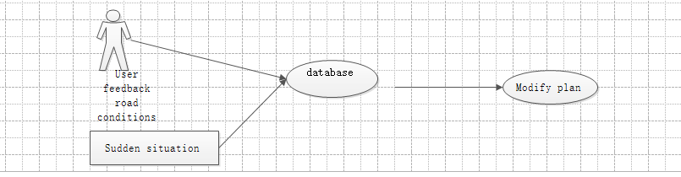

#### System Sequence Diagrams:

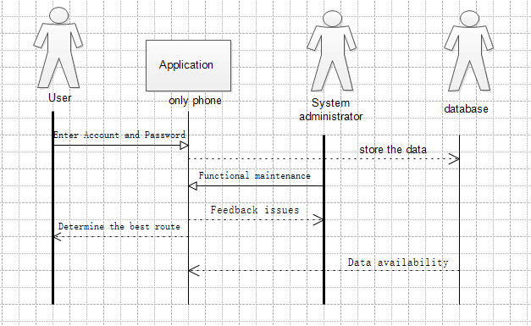

#### User Interface Specification：

According to the software function design, the user will go through the following steps：

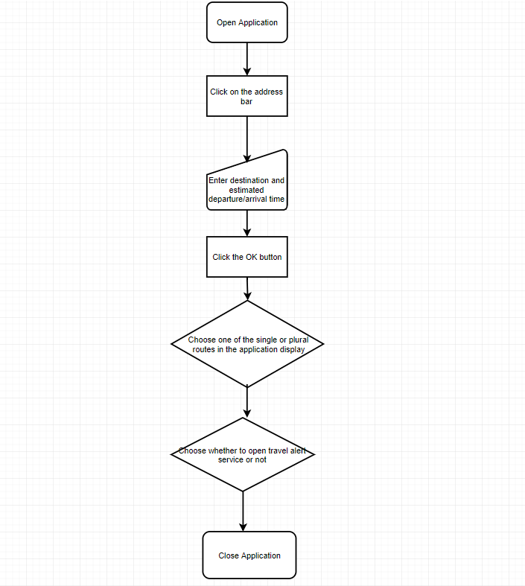

|  |  |  |
| --- | --- | --- |
| Operation | Example | Remarks |
| Open Application |  |  |
| Click on the address bar |  |  |
| Enter destination |  |  |
| Enter departure/arrival time |  | This function will be added to the navigation software. |
| Click the OK button |  |  |

|  |  |  |
| --- | --- | --- |
| Choose one of the single or plural routes in the application display |  | On this page, the departure and arrival times are expected to be added to the options for reference. |
| Choose whether to open travel alert service or not |  | This function is designed to avoid travel time forgetting caused by long time elapse. |
| Close Application |  |  |

Plan of Work :

Project Management

Our early work plan has a linear progression that breaks down the entire project into several parts. Then assigned to each group member. We hope that every part of the project will be completed smoothly. In order to improve work efficiency and quality of work, we divided the team into groups to do the following:

Initial Plan of work :

|  |  |  |  |
| --- | --- | --- | --- |
| Milestone | Original Deadline | Date completed | Group |
| Navigating data collection for user needs | 3/29 |  | Palmer and  Caden |
| Traffic data collection | 4/14 |  | William and  Chandler |
| Weather data collection | 5/3 |  | Guy and Jay |
| Initial database script | 5/17 |  | William and  Caden |
| Schedule a navigation route | 5/31 |  | Palmer and  Chandler |
| Traffic algorithm and direction algorithm | 15/6 |  | Guy and Jay |

Current achievement

1. Navigate the data collection of user needs, analyze the data, and determine the research direction.
2. Create a navigation system and user profile database
3. Flow algorithm, direction algorithm, traffic and weather prediction algorithm.
4. Improve the accuracy of traffic maps.
5. Design the user interface of the navigation software.
6. Traffic conditions and weather updates in real time.
7. Mobile traffic data report.
8. Scheduled reservation navigation service

Our current navigation software provides services on mobile mobile devices. Users can visit the website, log in and verify the user, and locate the location of the user in real time. The navigation software plans the best route and alternative route according to the user's needs. The traffic monitor is for the user. The navigation route is monitored in real time and fed back to the central management system to predict traffic and weather emergencies and to plan the most appropriate route. At the same time, our team also created an offline map database, using Beidou satellite to implement positioning, even in rural areas, suburbs and other areas with poor network signals can be navigated. The software page allows you to view traffic maps offline, 3D map mode, and emergency services. Compared to other navigation software, our products can provide scheduled appointment navigation route service, so we need to establish a reservation mode navigation route database. Finally, our data collection script runs without problems.

# Future of work :

For our current navigation software, we will do a lot of work in the future to improve and optimize the software to provide better services to users. The huge data information will destroy the existing database information, so it is very important to improve the user information

database. More accurate calculations of driving speed, time, weather, traffic and the user's current location. We can establish a database of information on traffic accidents based on the user's driving route and the location of the traffic accident, reminding users who will pass the accident site and providing appropriate driving speed or other routes. The accuracy of navigation depends on our algorithm, and we must improve and improve the algorithm. The traffic information database needs to be updated frequently so that users can view the latest traffic information. Improve the speed at which traffic monitors collect traffic accident information and be able to view road conditions. For the navigation system in the reservation mode, the requirements for planning the navigation route are very high. After the judgment of the traffic monitor, the comprehensive information such as the prediction of the weather satellite can finally plan the best route in advance. Therefore, we need to improve the accuracy of the number of road traffic monitors, flow algorithms, direction algorithms, traffic and weather prediction algorithms.